***Online Dashboard creation using Thingsboard***

***and***

***To push the data into Thingsboard using http protocol.***

1. Type <https://demo.thingsboard.io/> in web browser and create account.
2. Once you login, The following Home page will appear .

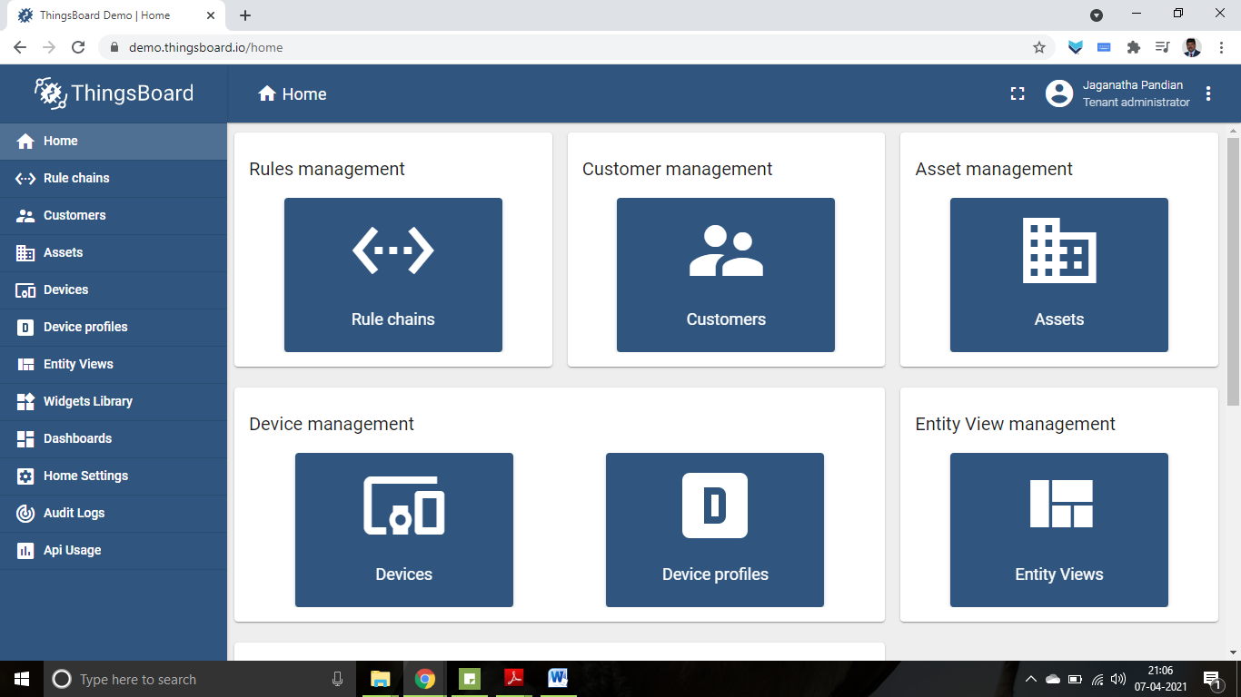

1. Click on “Devices” on the left hand side pane.
2. 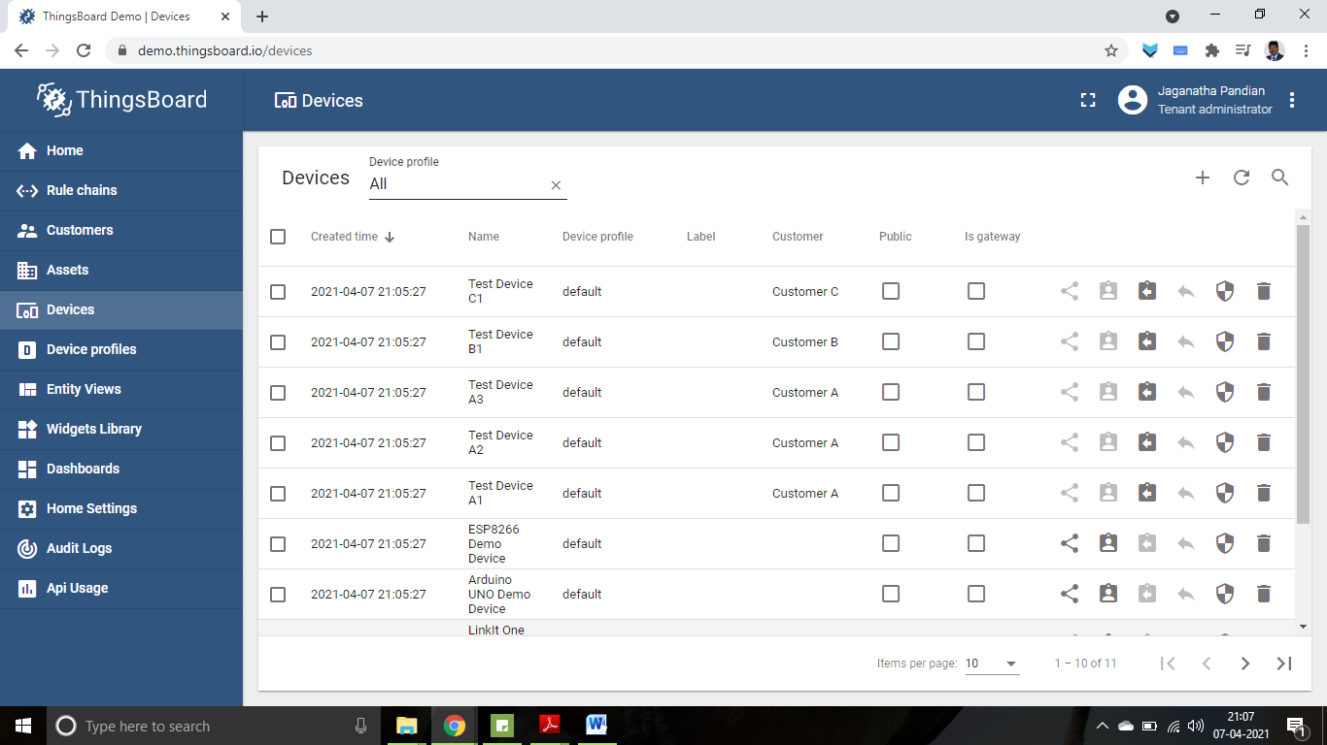
3. Click on [+] to add new device.
4. Provide details of new device

a. Name: Demo-iot- Reg. Number

b. Device type: Default

c. Label: my data

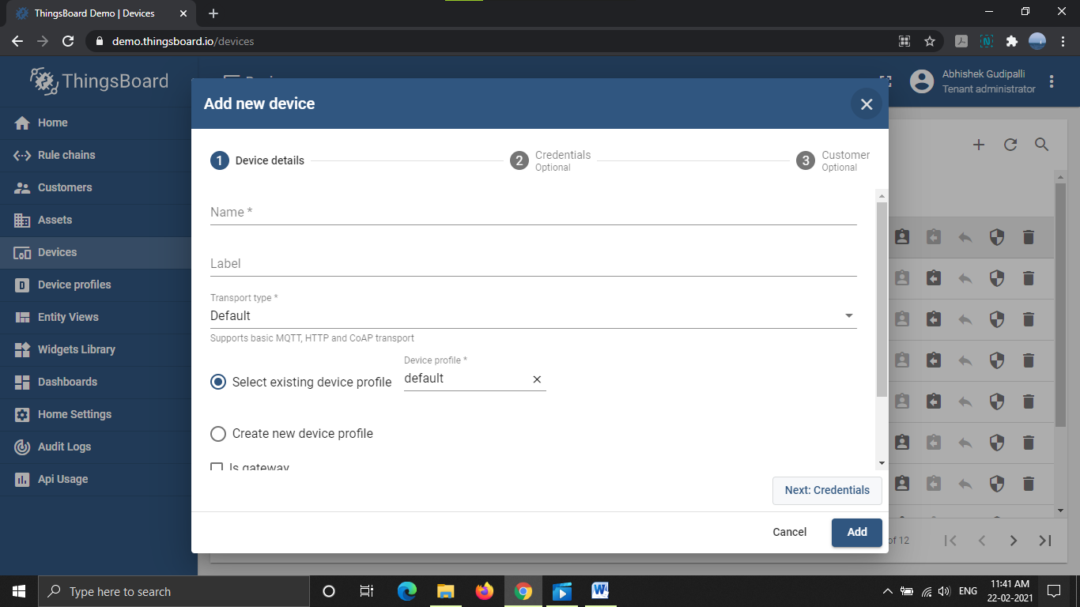Description: Demo

1. Click on Device, which is created and select “latest telemetry”, which provides the last data recorded.

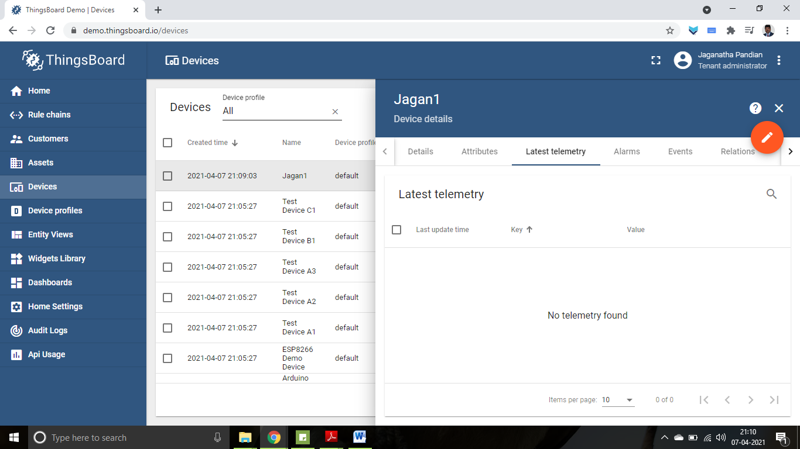

1. Select “details” and click on “copy access token” and paste it in notepad.

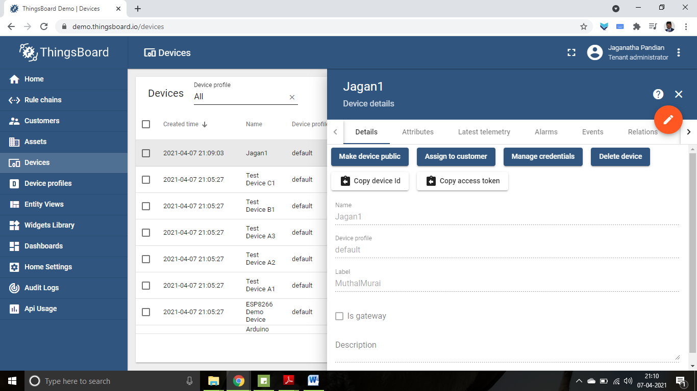

1. To push the data you can use either mqqt or http.
2. To use http, one of the easiest way is by using “curl”. This command will help you to post the data. If you are using the latest version of windows, curl is installed by default.
3. To check “curl” status, open CMD and type curl.
4. It will give response as “curl: try 'curl --help' for more information”
5. Type curl --help

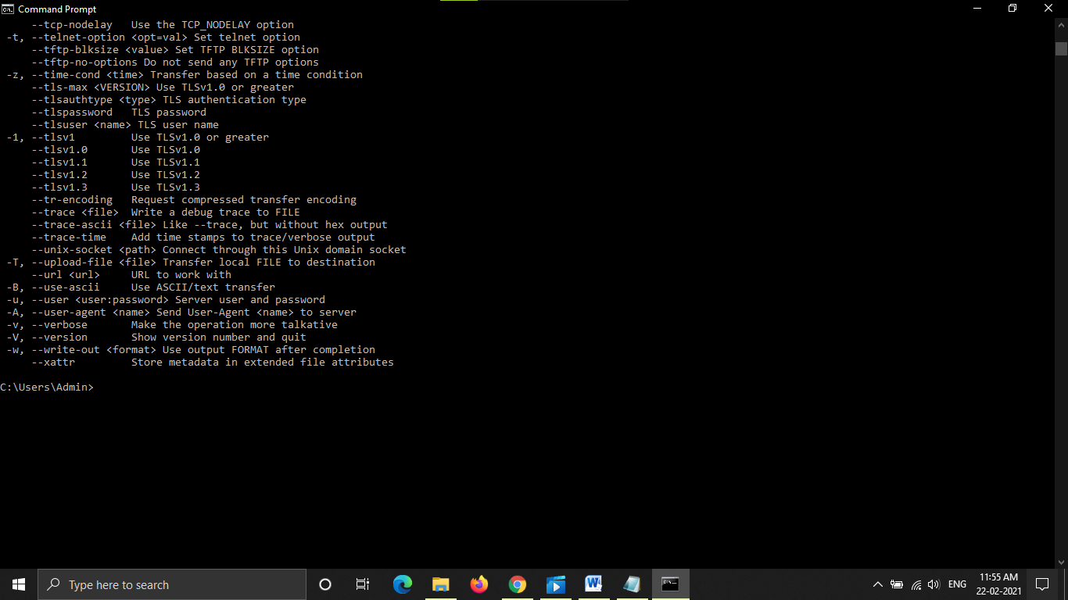

1. Use curl to push the data to thingsboard.
2. Copy and paste the below format –

curl -v -X POST -d "{\"Mysensor\": 59}" demo.thingsboard.io/api/v1/3VYMvkRm9XiqGIMbvhM8/telemetry --header "Content-Type:application/json"

1. The yellow shaded portion can be replaced with sensor name or parameter to be measured and green shaded portion can be replaced with the value you want to push.
2. The blue shaded portion can be replaced with access token.
3. Copy and paste the above modified format to push the data to things board

curl -v -X POST -d "{\"IOTsensor\": 59}" demo.thingsboard.io/api/v1/optptDe95fpGK0Qr0MKB/telemetry --header "Content-Type:application/json"

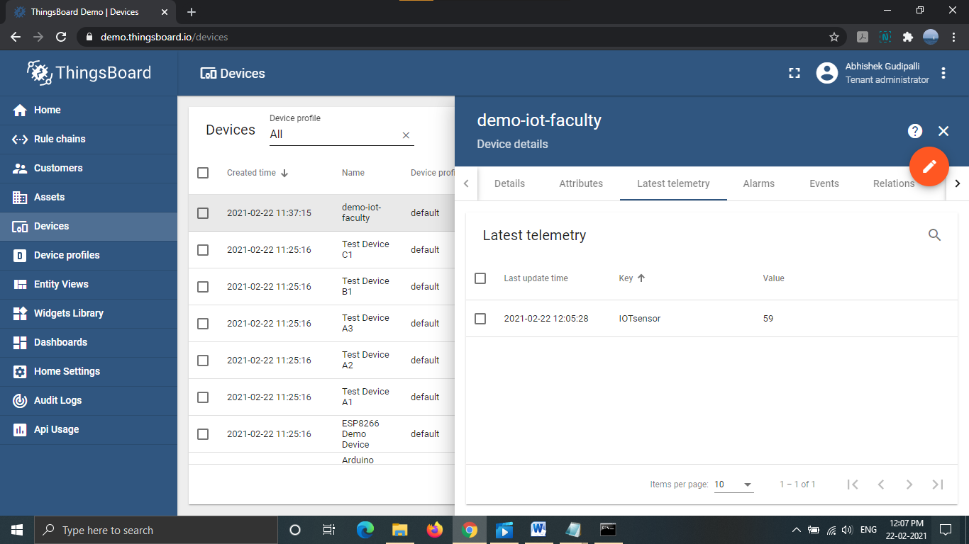

1. Click on Dashboards and create new dashboard.

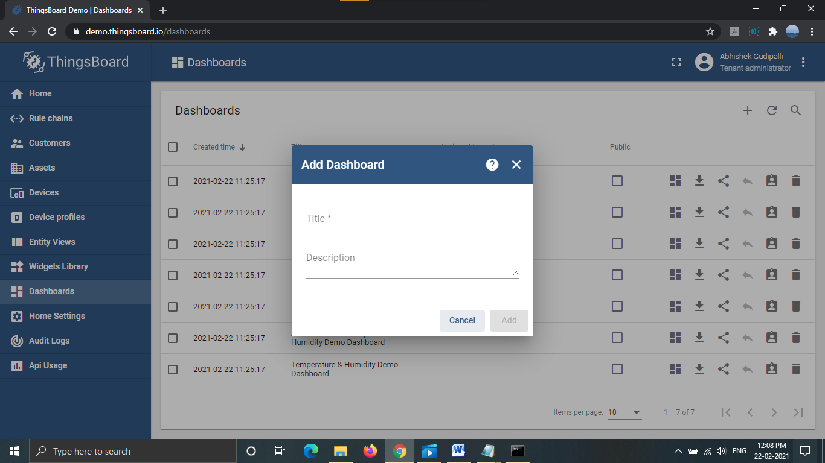

1. Click on Open dashboard

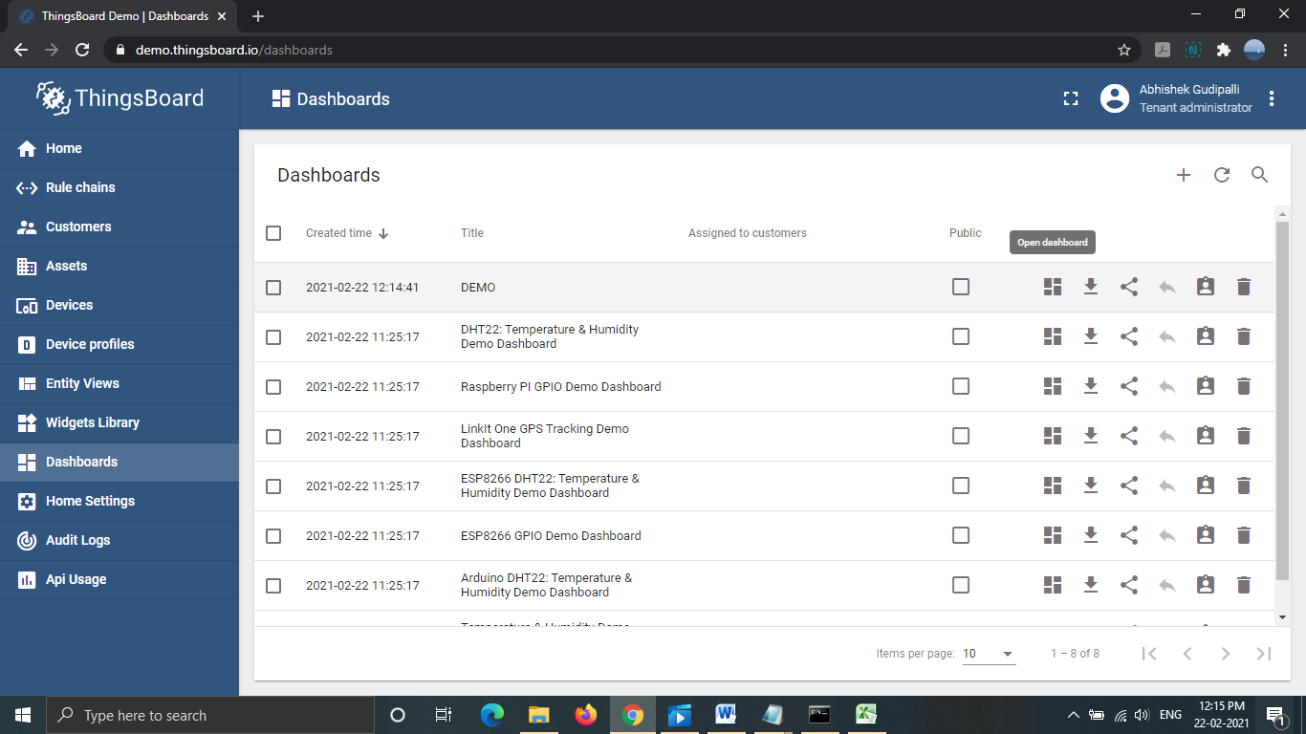

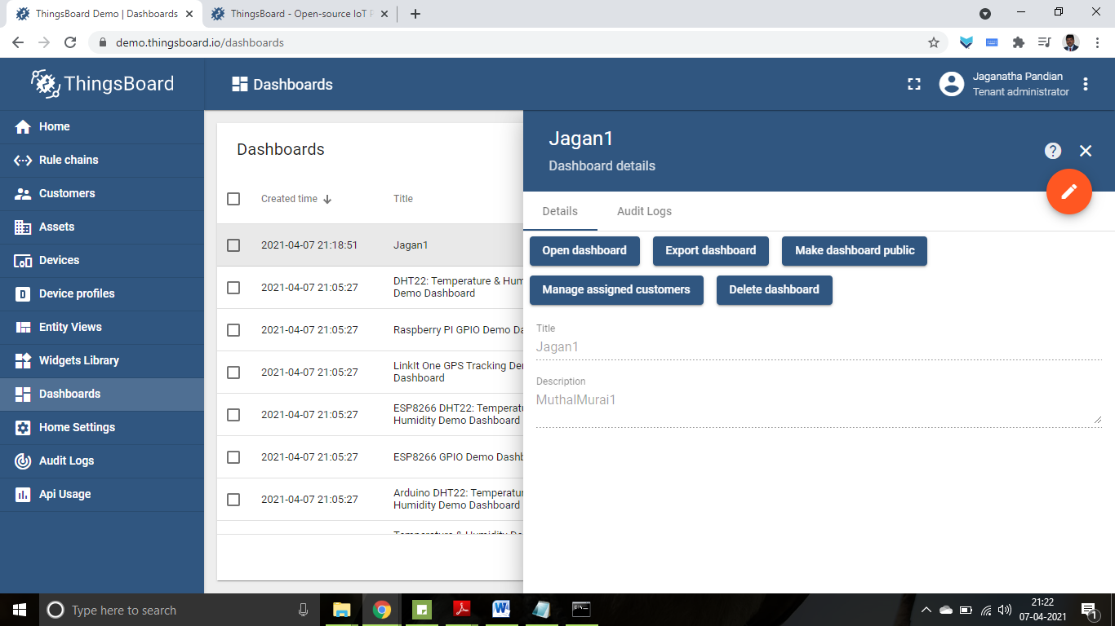

1. Click on Orange colour edit button available at bottom and add new widget

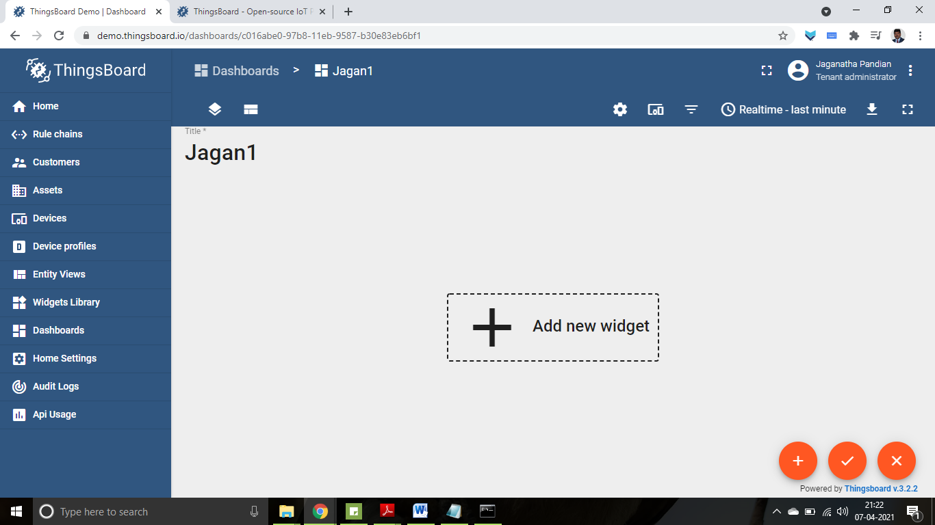

1. Click on Add new widget to add widget to dashboard.
2. Select Add data sources.

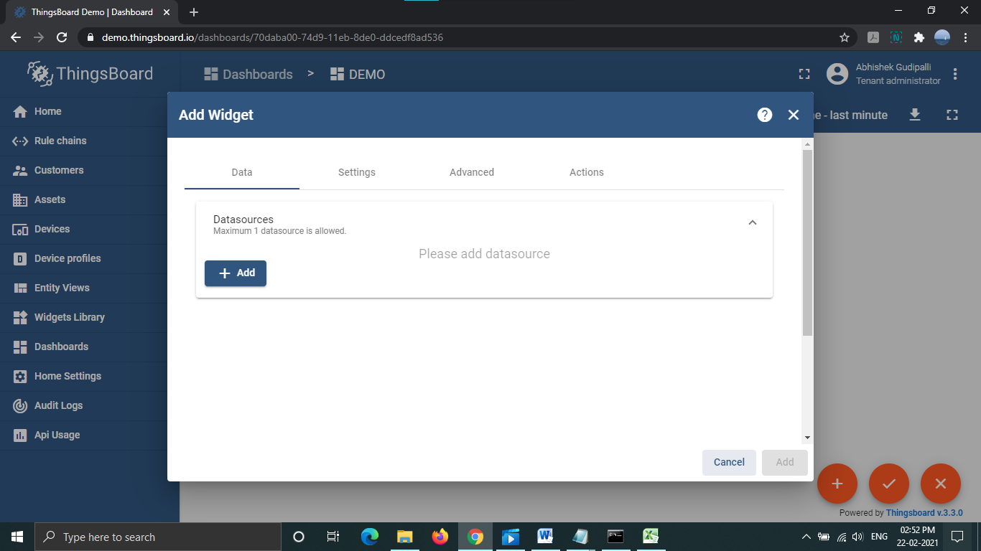

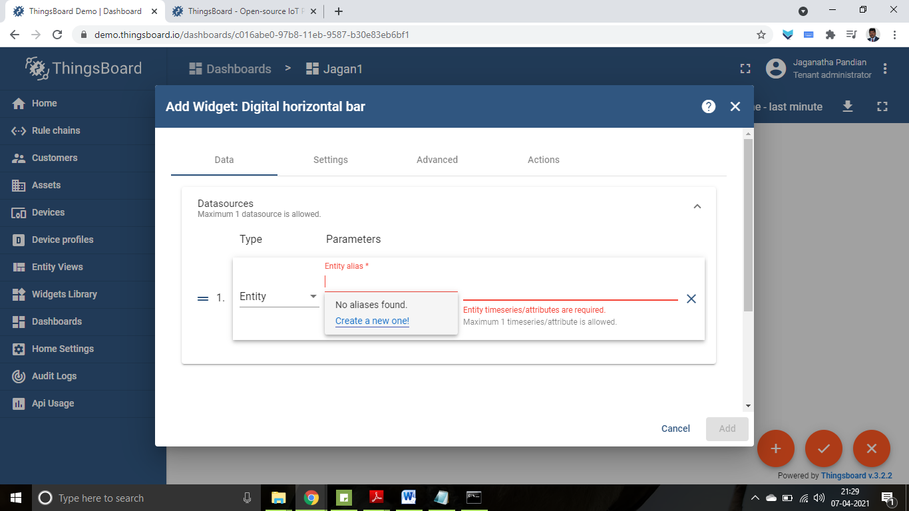

1. Select Entity and create Entity alias with name, filter type [Since we created device select Device type], Device type [Type Default] and mention Device name created earlier.

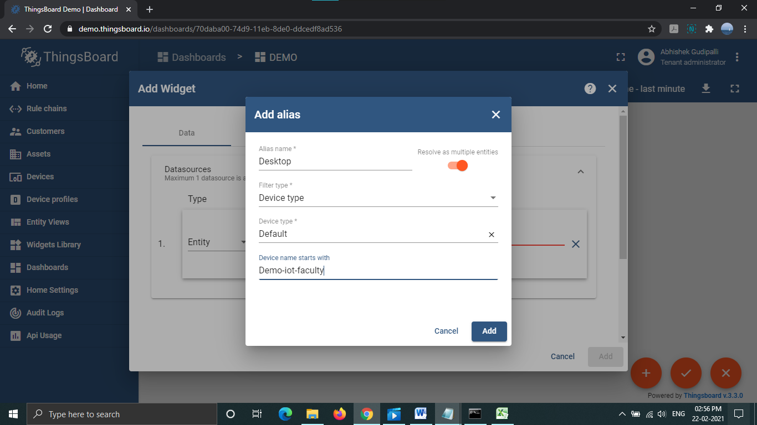

1. Select the sensor and display the value in the widget.

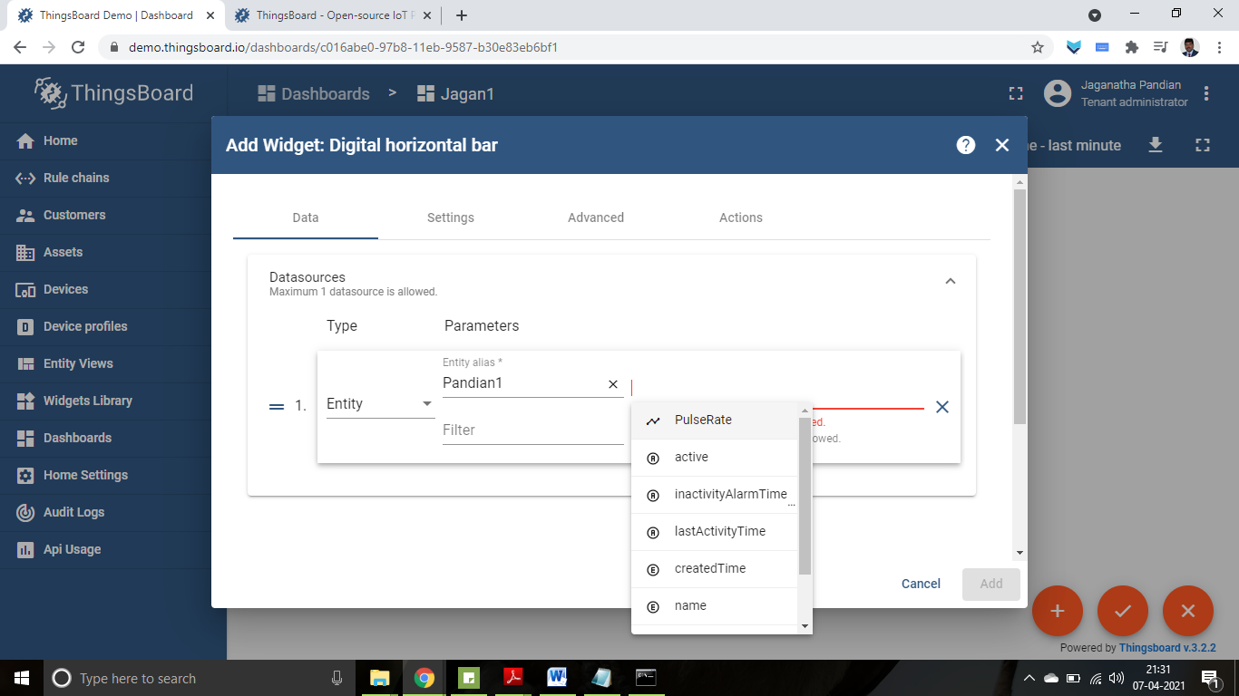

1. The value is displayed in widget.

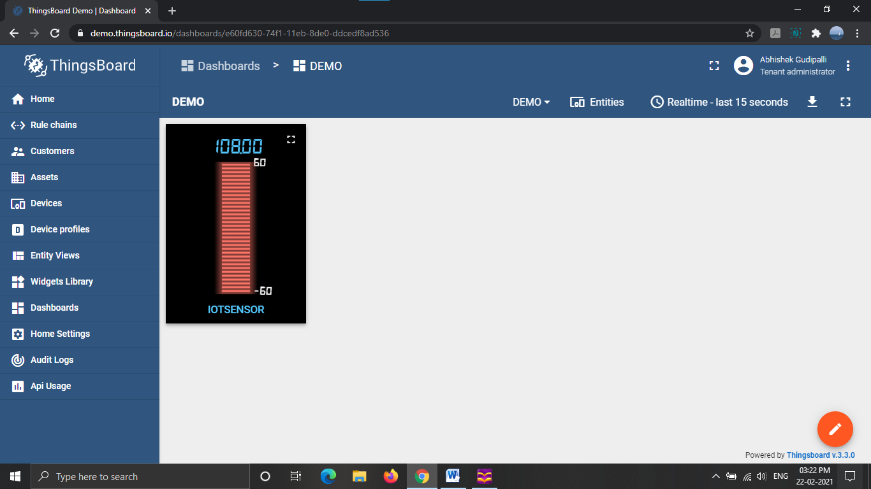

1. Provide the data manually and push it to visualise in the widget by using the following curl function in cmd.

curl -v -X POST -d "{\"IOTsensor\": 108}" demo.thingsboard.io/api/v1/optptDe95fpGK0Qr0MKB/telemetry --header "Content-Type:application/json"